Sneakers
Iteration Planning
Meeting Minutes
George Dean, Craig Hokanson, Jason Leng, Sion Chaudhuri
11/08/2011

This document contains the planning minutes, tasks associated with story cards, and progress charts for each iteration.

Table of Contents
Iteration 1 2
Planning meeting minutes 2
Monday (9/26) 3
Wednesday (9/28) 3
Thursday (9/29) 4
Tasks associated with story cards 4
Create Project 5
Create Stock Deliverable 6
View Project 7
Create Custom Deliverable 8
View Lifecycle 9
Ordering and Priority of Story Cards 10
Charts 11
Burn up chart for current iteration 11
Burn down chart for total project 12
Iteration 2 13
Planning meeting minutes 13
Tuesday (10/25) 13
Tasks associated with story cards 15
Create Custom Deliverable 15
Automatic Unit of Measure 16
View Deliverable 17
Modify Stock Deliverable 18
Modify Custom Deliverable 19
Ordering and Priority of Story Cards 20
Charts 21
Burn up chart for current iteration 21
Burn down chart for total project 22

Timeline

Story Card | Iteration 1 | Iteration 2 | Iteration 3
Create Project | ✔
View Project | ✔
Create Stock Deliverable | ✔
View Lifecycle | ✔
Automatic Unit of Measure |  | ✔
Create Custom Deliverable |  | ✔
View Deliverable |  | ✔
Modify Stock Deliverable |  | ✔
Modify Custom Deliverable |  | ✔
Historical Data |  |  | ✔
Log Effort |  |  | ✔
User Login |  |  | ✔
Regular User Role |  |  | ✔
Delete Deliverable |  |  | ✔
Admin User Role |  |  | ✔
Create Lifecycle |  |  | ✔
Create Lifecycle Phase |  |  | ✔
Reorder Lifecycle Phase |  |  | ✔

Iteration 1

Planning meeting minutes
Iteration 1 planning was split over three sessions on Monday (9/26), Tuesday (9/27) and Wednesday (9/28).

Monday (9/26)
- Begin generating task cards for each story card
  - Finished three story cards.
  - Will have impromptu team meeting during George-Sion pairing time on Wednesday 5pm - 7pm to finish generating task cards.
- Identify plans for future pairings
  - Jason - Craig (Tuesday)
    - Checkout our repository and do any basic setup/cleanup that needs doing.
    - Come up with a proposed architecture for the system. Extreme programming discourages Big-Design-Up-Front, but my understanding is that a design spike for an hour or two at the beginning of an iteration is encouraged.
- Identify Individual action items
  - Jason
    - Move documents from Google Docs to Git.
- Notes
  - We will be switching away from Google Docs for storage of documents. We will be using Git instead.
- Debrief
  - Ran out of time to accomplish meeting goals.

Wednesday (9/28)
- Discuss progress since Monday
  - Craig-Jason pairing
    - Worked on design
    - Scaffold project
    - Generate lifecycle model
    - Removed editing/deleting links from views
    - Created RSpec tests
  - Craig-George pairing
    - Revised design slightly
    - Added in Units of Measure and Complexity
      - Not ActiveRecord models
    - Started to create a lifecycle combo box on the new project page
    - Started making transition to PostgreSQL
- Finish breaking story cards into task cards
- Look at deliverables for this iteration
- Establish deliverables to focus on
  - Writing code to implement story cards
  - Design documents (for each task card?)
- Identify plans for future pairings
- Identify individual action items
- Debrief
  - Found a time to continue the planning meeting
  - Need to setup longer iteration planning meeting in the future
  - Keep running out of time

Thursday (9/29)
- Discuss Jason’s design idea
  - Revise task cards if necessary
- Estimate task cards in Pivotal Tracker
- Look at deliverables for this iteration (~11.5 hours total)
  - Iteration Planning Meeting Minutes: 80 minutes
  - Weekly cycle meeting minutes: 45 minutes
  - The product
    - Design Document: 8 hours
  - XP Process Review (bowtie): 75 minutes
- Consider alterations to schedule to make iteration planning viable
  - Scheduled iteration planning meetings on the first Tuesday night of the iteration
- Consider alterations to schedule to get deliverables complete for this iteration
  - Need 22 hours for coding
  - Need 12 hours for documentation
  - Need 4 hours of slack
  - Need 19 hours of pairing each week
  - Currently have 12 hours
  - Need 7 hours more per week
- Identify plans for future pairings
  - Create a mockup for the create custom deliverable modal dialog
  - Make time for deliverables for this iteration, in addition to coding
- Develop Git workflow document
- Review build server postgres settings
- Identify individual action items

Tasks associated with story cards
We recorded the tasks for each story card in Pivotal Tracker.

Create Project
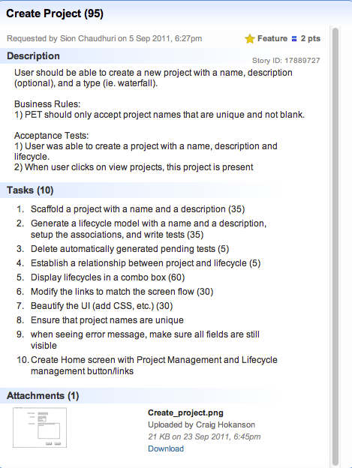

Create Stock Deliverable
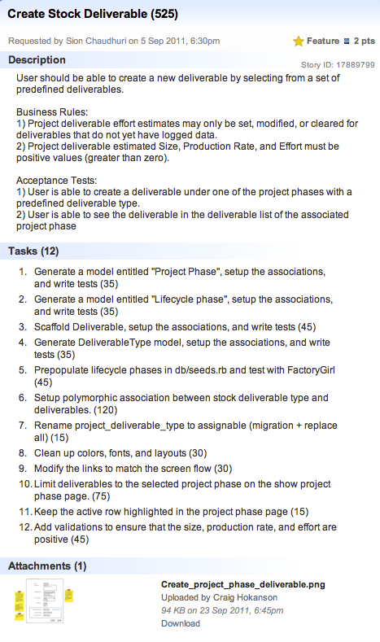

View Project
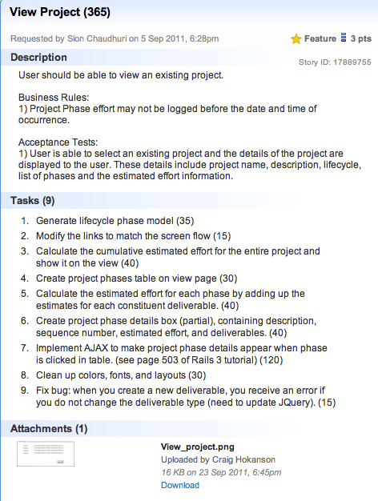

Create Custom Deliverable
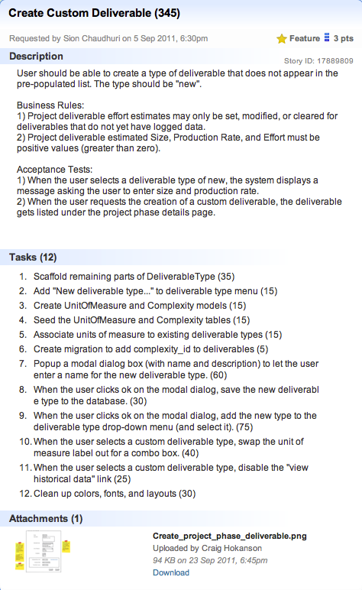

View Lifecycle
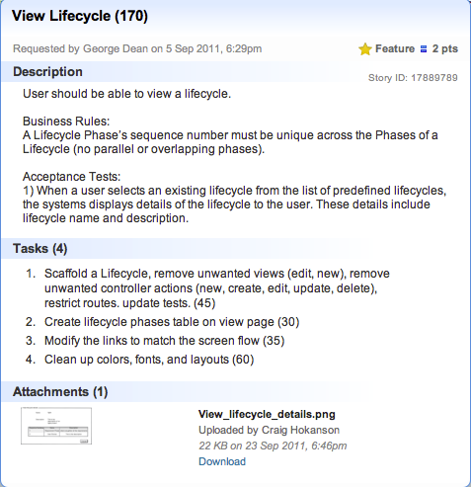

Ordering and Priority of Story Cards
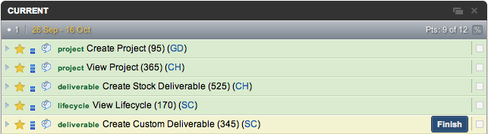

Charts
The following burn up and burn down charts were generated by pivotal tracker.

Burn up chart for current iteration
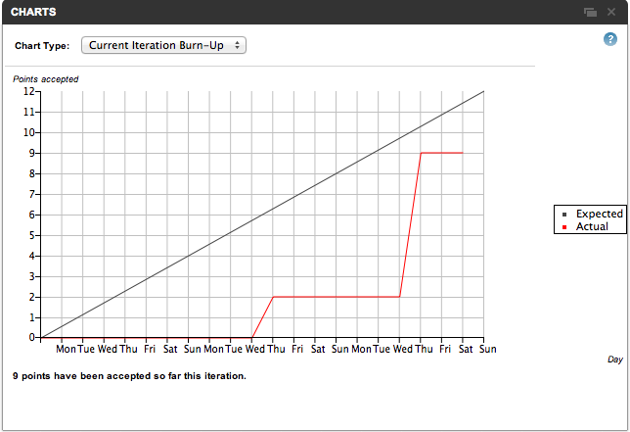

Burn down chart for total project
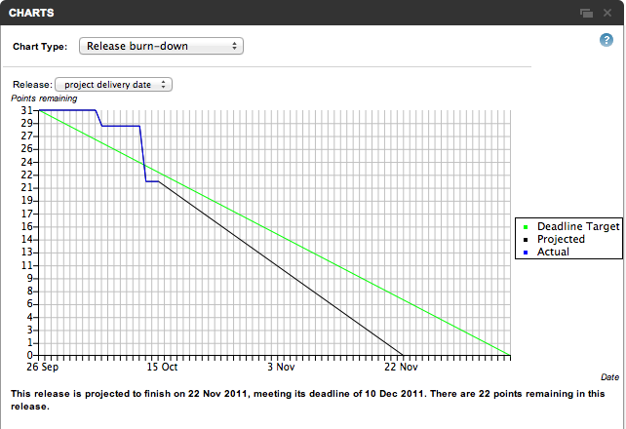

Iteration 2

Reflection on prior iteration
- Review stories implemented in last iteration. How well did our actual progress match our expectations?
  - Achieved goals
    - Stories
      - Create Project
      - View Project
      - Create Stock Deliverable
      - View Lifecycle
      - Other
        - Created demo seeds to populate database
    - Missed goals
      - Create Custom Deliverable
  - What was our velocity?
    - 9
  - What went well?
    - Our web application was second only to GandalFirl
    - Meetings at Sion’s house went well
    - Worked very consistently; no spike in effort
  - What could be improved?
    - Our web application was second to GandalFirl
    - Put a stronger focus on styling

Planning meeting minutes
Iteration 2 planning was started and completed on Tuesday (10/25).

Tuesday (10/25)
- Identify a theme for this iteration
  - Deliverables
- Establish goals for this iteration
  - Stories
    - Create custom deliverable
    - View deliverable
    - Modify stock deliverable
    - Modify custom deliverable
    - Automatic unit of measure
  - Deliverables
    - Iteration Planning Meeting Minutes
    - Weekly Cycle Meeting Minutes
    - Design document
    - Readme
    - XP Process Review
    - Myers Briggs Briefings
  - Chores
    - Improve CSS styling
    - JQuery look-and-feel improvement
- Other considerations
  - Should we walk through our workflow and consider it from a user-centric approach? What can we change to make it more user-friendly?
  - Proposal: spend a Saturday working entirely on making the UI beautiful.
    - Need to create specific plans.
    - Seems like a reasonable plan (Sion not available this Saturday)
- Task planning
  - Generate task cards for each story card that is in scope
  - Identify high risk deliverables to focus on early
    - Design document
    - Myers Briggs Briefings
- Estimation
  - Estimate task cards in Pivotal Tracker
  - Estimate story cards by adding together task estimates and adding in slack
    - Create Custom Deliverable
      - 695 + 140 slack = 835 minutes total
    - View Deliverable
      - 90 + 20 slack = 110 minutes total
    - Automatic Unit of Measure
      - 150 + 30 slack = 180 minutes total
    - Modify Stock Deliverable
      - 405 + 80 slack = 485 minutes total
    - Modify Custom Deliverable
      - 120 + 25 slack = 145 minutes total
    - Total: 1755 minutes
  - Estimate deliverables
    - Iteration Planning Meeting Minutes
      - 30 minutes
    - Weekly Cycle Meeting Minutes
      - 30 minutes
    - Design document (add code comments)
      - 150 minutes
    - Readme
      - 20 minutes
    - XP Process Review
      - 0 team time
    - Myers Briggs Team Meeting
      - 60 minutes
    - Total: 290 minutes
  - Estimate total work by adding together story estimates and deliverable estimates
    - 1755 + 290 = 2045 minutes = 34 hours
- Scheduling
  - Compare work estimates with schedule; adjust schedule accordingly
  - We are currently scheduled for 46, so we should be good to complete all 34 hours within our schedule

Tasks associated with story cards
We recorded the tasks for each story card in Pivotal Tracker.

Create Custom Deliverable
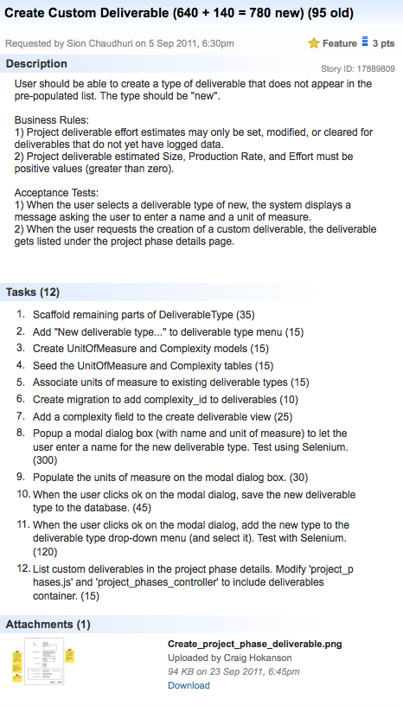

Automatic Unit of Measure
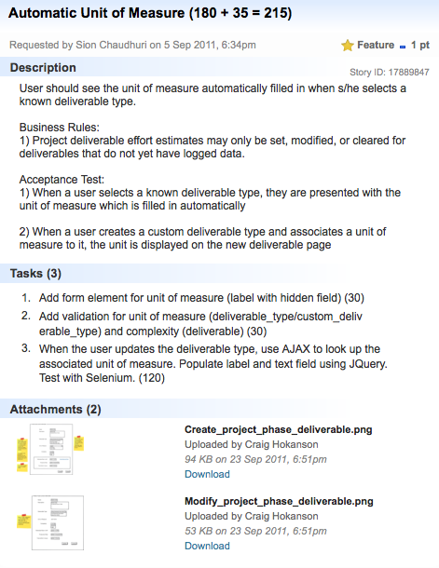

View Deliverable
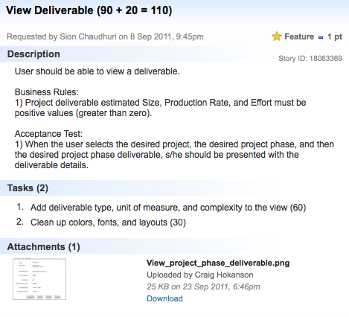

Modify Stock Deliverable
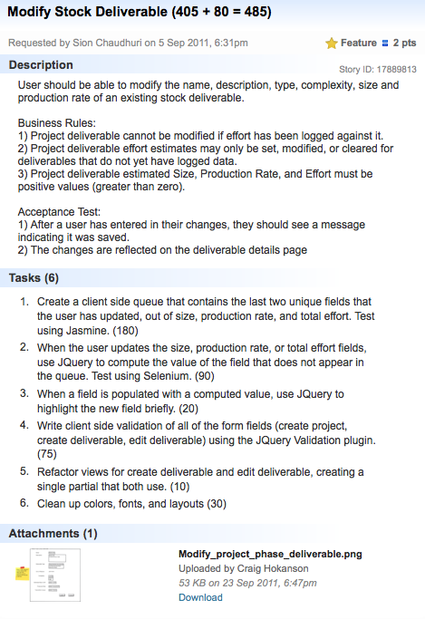

Modify Custom Deliverable
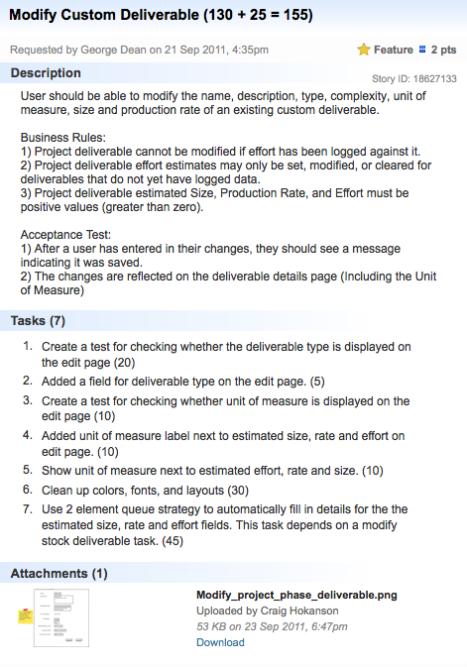

Ordering and Priority of Story Cards
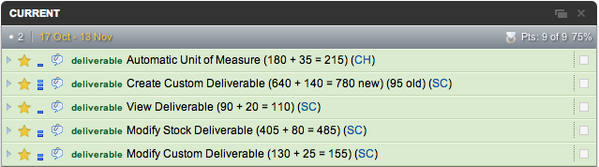

Charts
The following burn up and burn down charts were generated by pivotal tracker.

Burn up chart for current iteration
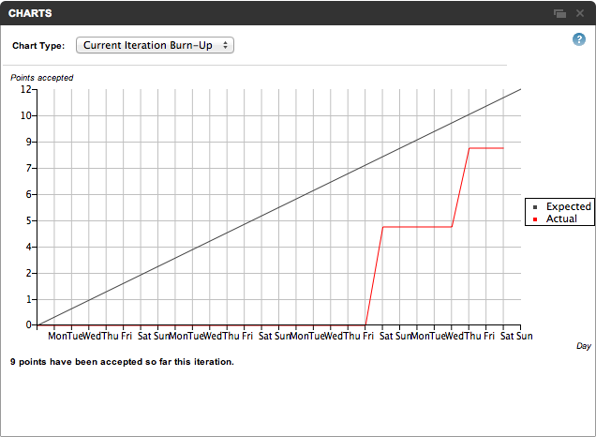

Burn down chart for total project
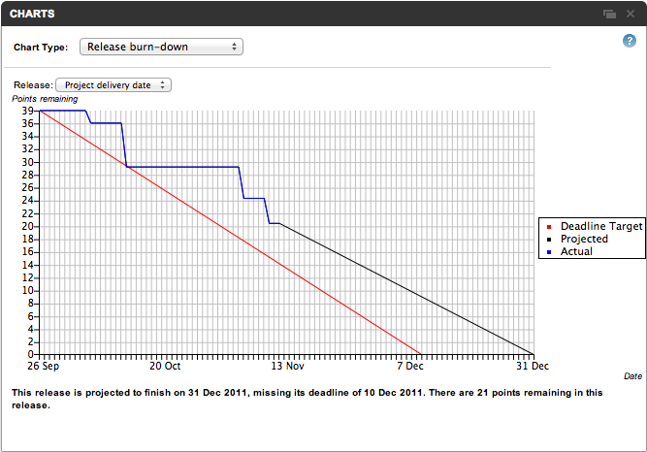

Iteration 3

Reflection on prior iteration
- Review stories implemented in last iteration. How well did our actual progress match our expectations?
  - Achieved goals
    - Implemented user stories
      - Automatic unit of measure
      - Create custom deliverable
      - View deliverable
      - Modify stock deliverable
      - Modify custom deliverable
    - Deliverables
      - Iteration Planning Meeting Minutes
      - Weekly Cycle Meeting Minutes
      - Design document
      - Readme
      - XP Process Review
      - Myers Briggs Briefings
    - Chores
      - Improve CSS styling
      - JQuery look-and-feel improvement
  - Missed goals
    - None
- What was our velocity?
  - 9
- What went well?
  - Met every single goal, missed none
  - Design and styling session went well and yielded excellent results
  - Estimation was improved from first iteration
- What could be improved?
  - Estimation was way too low

Planning meeting minutes
Iteration 3 planning was started and completed on Tuesday (11/15).

Tuesday (11/15)
- Prioritize story cards
- Establish goals for this iteration
  - Stories
    - Historical Data
    - Log Effort
    - User Login
    - Regular User Role
    - Delete Deliverable
    - Admin User Role
    - Create Lifecycle
    - Create Lifecycle Phase
    - Reorder Lifecycle Phase
  - Deliverables
    - Weekly cycle meeting minutes
    - Iteration meeting minutes
    - XP Process Review
    - Updated Design documents
      - Data dictionary
      - User requirements
    - Final Presentation
  - Chores
    - Continue updating styling if we have time
    - Add seed data if we have time
  - Final Presentation
- Task planning
  - Generate task cards for each story card that is in scope
    - http://iqbalfarabi.net/2010/11/26/rails-3-authentication-and-authorization-with-devise-and-cancan-part-1/
    - http://www.tonyamoyal.com/2010/07/28/rails-authentication-with-devise-and-cancan-customizing-devise-controllers/
    - http://www.tonyamoyal.com/2010/09/29/rails-authentication-with-devise-and-cancan-part-2-restful-resources-for-administrators/
  - Identify high risk deliverables to focus on early
- Estimation
  - Estimate task cards in Pivotal Tracker
  - Estimate story cards by adding together task estimates and adding in slack (2760 minutes = 46 hours)
    - Historical Data (495 + 75 = 570)
    - Log Effort (345 + 50 = 395)
    - User Login (150 + 25 = 175)
    - Regular User Role (185 + 30= 215)
    - Delete Deliverable (185 + 30 = 215)
    - Admin User Role (435 + 65 = 500)
    - Create Lifecycle (80 + 15 = 95)
    - Create Lifecycle Phase (285 + 45 = 330)
    - Reorder lifecycle phase (230 + 35 = 265)
  - Estimate deliverables (420 minutes = 7 hours)
    - Weekly cycle meeting minutes (50)
    - Iteration meeting minutes (70)
    - XP Process Review (0)
    - Updated Design documents
      - Add code comments (90)
      - Data dictionary (60)
      - User requirements (60)
      - Model Associations (25)
      - README (20)
      - DIA class diagram (45)
  - Estimate Final Presentation
    - 0 pair session time
  - Estimate total work by adding together story estimates, deliverable estimates, and slack time
    - Story cards: 46 hours
    - Deliverables: 7 hours
    - Total: 53 hours
- Scheduling
  - Compare work estimates with schedule; adjust schedule accordingly
    - 51 hours of pair sessions remain in the rest of this iteration
    - 5.5 hours have already been completed

Tasks associated with story cards
We recorded the tasks for each story card in Pivotal Tracker.

Historical Data

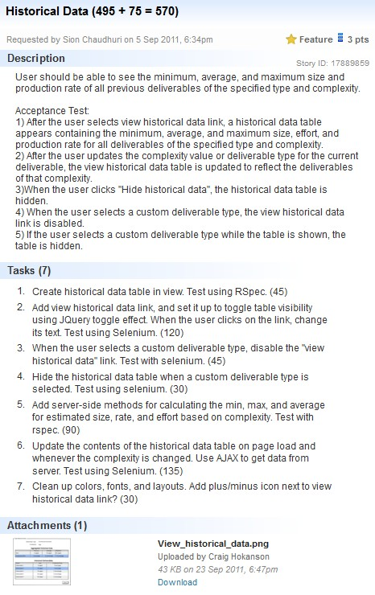

Log Effort

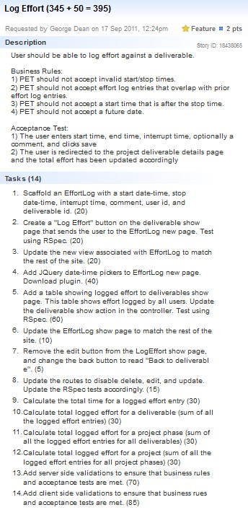

User Login

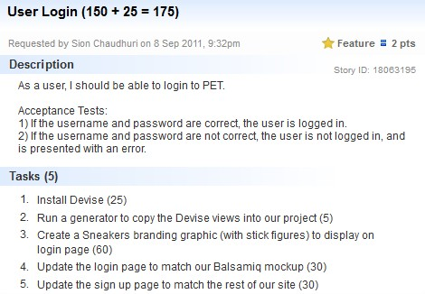

Regular User Role
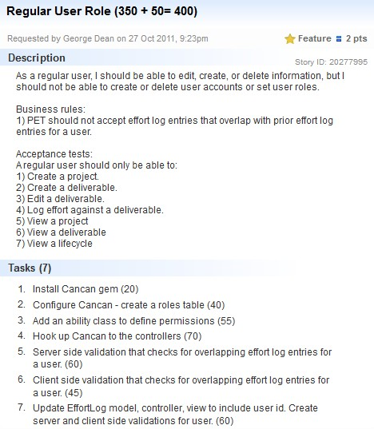

Delete Deliverable
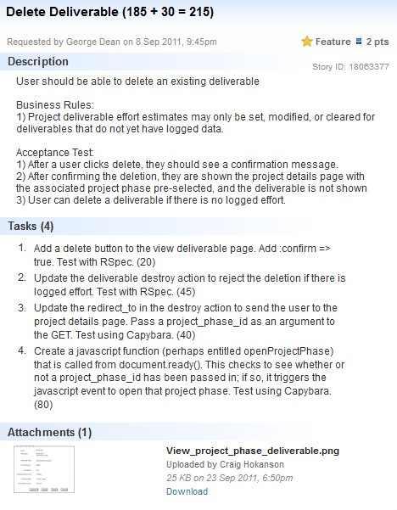

Admin User Role
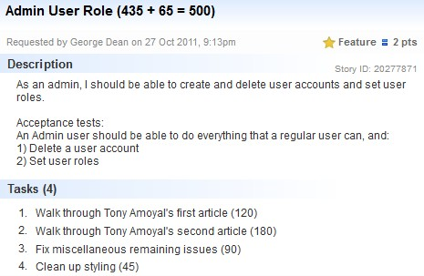

Create Lifecycle

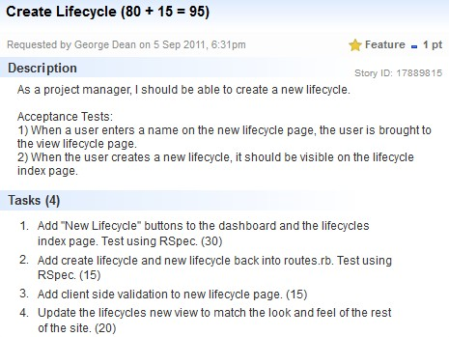

Create Lifecycle Phase

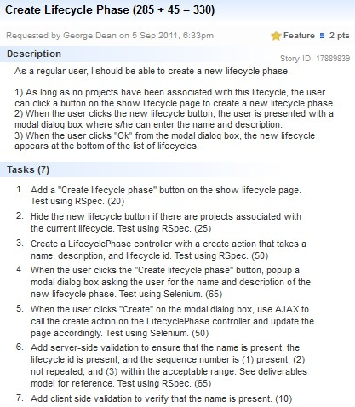

Reorder Lifecycle Phase

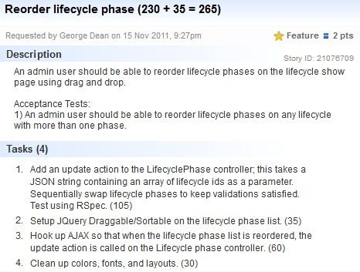

Ordering and Priority of Story Cards

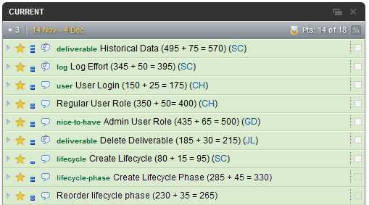

Charts
The following burn up and burn down charts were generated by pivotal tracker.

Burn up chart for current iteration

Burn down chart for total project

Reflection on this iteration
- Review stories implemented in final iteration. How well did actual progress match expected progress?
  - Achieved goals
    - Story cards
      - Historical Data
      - Log Effort
      - User Login
      - Regular User Role
      - Delete Deliverable
      - Create Lifecycle
      - Create Lifecycle Phase
      - Reorder lifecycle Phase
    - Deliverables
      - Weekly cycle meeting minutes
      - Iteration meeting minutes
      - Data dictionary
      - User requirements
      - Model Associations
      - README
      - XP Process Review
      - DIA class diagram
      - Updated Design documents
- What was our velocity?
  - 18
- What went well?
  - We did not put off work on our final presentation until the last moment, which would have been a likely outcome given the high workload on the product. We worked on the final presentation consistently throughout the whole iteration.
  - Able to schedule around various team member trips successfully
  - Our estimations are getting more accurate
  - We front-loaded this iteration, which removed the risk that we would not be able to complete our tasks
  - We worked really well as a team
- What could be improved?
  - We should have committed to a smaller scope.
  - We had no backup plan for loss of internet connection, which was a recurring theme

